Lab # 7

**Design Patterns: Structural Patterns**

**OBJECTIVE**

* Understand structural design patterns: Adapter Pattern.

**Theory:**

**Structural Patterns:**

In software engineering, **structural design patterns** are design patterns that ease the design by identifying a simple way to realize relationships among entities.

Examples of Structural Patterns include:

* Adapter pattern: 'adapts' one interface for a class into one that a client expects
* Aggregate pattern: a version of the Composite pattern with methods for aggregation of children
* Bridge pattern: decouple an abstraction from its implementation so that the two can vary independently
* Composite pattern: a tree structure of objects where every object has the same interface
* Decorator pattern: add additional functionality to a class at runtime where subclassing would result in an exponential rise of new classes
* Extensibility pattern: a.k.a. Framework - hide complex code behind a simple interface
* Facade pattern: create a simplified interface of an existing interface to ease usage for common tasks
* Flyweight pattern: a large quantity of objects share a common properties object to save space
* Marker pattern: an empty interface to associate metadata with a class.
* Pipes and filters: a chain of processes where the output of each process is the input of the next
* Opaque pointer: a pointer to an undeclared or private type, to hide implementation details
* Proxy pattern: a class functioning as an interface to another thing

1. **Adapter Pattern**

Adapter pattern works as a bridge between two incompatible interfaces. This type of design pattern comes under structural pattern as this pattern combines the capability of two independent interfaces.

This pattern involves a single class which is responsible to join functionalities of independent or incompatible interfaces. A real life example could be a case of card reader which acts as an adapter between memory card and a laptop. You plugin the memory card into card reader and card reader into the laptop so that memory card can be read via laptop.

We are demonstrating use of Adapter pattern via following example in which an audio player device can play mp3 files only and wants to use an advanced audio player capable of playing vlc and mp4 files.

We have a *Media Player* interface and a concrete class *AudioPlayer*implementing the *MediaPlayer* interface. *AudioPlayer* can play mp3 format audio files by default.

We are having another interface *AdvancedMediaPlayer* and concrete classes implementing the *AdvancedMediaPlayer* interface. These classes can play vlc and mp4 format files.

We want to make *AudioPlayer* to play other formats as well. To attain this, we have created an adapter class *MediaAdapter* which implements the *MediaPlayer* interface and uses *AdvancedMediaPlayer* objects to play the required format.

*AudioPlayer* uses the adapter class *MediaAdapter* passing it the desired audio type without knowing the actual class which can play the desired format. *AdapterPatternDemo*, our demo class will use *AudioPlayer* class to play various formats.

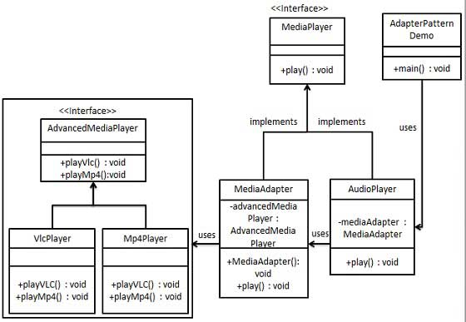

**Java Code:**

**Step 1**

**Create interfaces for Media Player and Advanced Media Player.**

*MediaPlayer.java*

public interface MediaPlayer {

public void play(String audioType, String fileName);

}

*AdvancedMediaPlayer.java*

public interface AdvancedMediaPlayer {

public void playVlc(String fileName);

public void playMp4(String fileName);

}

**Step 2**

**Create concrete classes implementing the *AdvancedMediaPlayer* interface.**

*VlcPlayer.java*

public class VlcPlayer implements AdvancedMediaPlayer{

@Override

public void playVlc(String fileName) {

System.out.println("Playing vlc file. Name: "+ fileName);

}

@Override

public void playMp4(String fileName) {

//do nothing

}}

*Mp4Player.java*

public class Mp4Player implements AdvancedMediaPlayer{

@Override

public void playVlc(String fileName) {

//do nothing

}

@Override

public void playMp4(String fileName) {

System.out.println("Playing mp4 file. Name: "+ fileName);

}

}

**Step 3**

**Create adapter class implementing the *MediaPlayer* interface.**

*MediaAdapter.java*

public class MediaAdapter implements MediaPlayer {

AdvancedMediaPlayer advancedMusicPlayer;

public MediaAdapter(String audioType){

if(audioType.equalsIgnoreCase("vlc") ){

advancedMusicPlayer = new VlcPlayer();

}else if (audioType.equalsIgnoreCase("mp4")){

advancedMusicPlayer = new Mp4Player();

}

}

@Override

public void play(String audioType, String fileName) {

if(audioType.equalsIgnoreCase("vlc")){

advancedMusicPlayer.playVlc(fileName);

}

else if(audioType.equalsIgnoreCase("mp4")){

advancedMusicPlayer.playMp4(fileName);

}

}

}

**Step 4**

**Create concrete class implementing the *MediaPlayer* interface.**

*AudioPlayer.java*

public class AudioPlayer implements MediaPlayer {

MediaAdapter mediaAdapter;

@Override

public void play(String audioType, String fileName) {

//inbuilt support to play mp3 music files

if(audioType.equalsIgnoreCase("mp3")){

System.out.println("Playing mp3 file. Name: " + fileName);

}

//mediaAdapter is providing support to play other file formats

else if(audioType.equalsIgnoreCase("vlc") || audioType.equalsIgnoreCase("mp4")){

mediaAdapter = new MediaAdapter(audioType);

mediaAdapter.play(audioType, fileName);

}

else{

System.out.println("Invalid media. " + audioType + " format not supported");

} } }

**Step 5**

**Use the AudioPlayer to play different types of audio formats.**

*AdapterPatternDemo.java*

public class AdapterPatternDemo {

public static void main(String[] args) {

AudioPlayer audioPlayer = new AudioPlayer();

audioPlayer.play("mp3", "beyond the horizon.mp3");

audioPlayer.play("mp4", "alone.mp4");

audioPlayer.play("vlc", "far far away.vlc");

audioPlayer.play("avi", "mind me.avi");

}

}

**Output:**

**Step 6**

**Verify the output.**

Playing mp3 file. Name: beyond the horizon.mp3

Playing mp4 file. Name: alone.mp4

Playing vlc file. Name: far far away.vlc

Invalid media. avi format not supported

**Exercise:**

Create interfaces, concrete and adapter classes implementing the interface of your scenario.